Contents

INTRODUCTION: 2

AIM: 2

THEORY: 2

MATERIALS AND EQUIPTMENT REQUIRED: 5

OBSERVATIONS: 6

TABLE: 7

COMPARISION WITH THEORY: 7

CONCLUSION AND DISSCUSSION: 7

ADDITIONAL DISCUSSION: 8

REFRENCES: 8

### INTRODUCTION:

The Vickers Hardness Test is a widely used method for measuring the hardness of materials, particularly metals and alloys, based on the principle of indentation. A diamond pyramid-shaped indenter is pressed into the material under a specific load, and the size of the resulting indentation is measured to determine the hardness value. This experiment is crucial for evaluating a material’s resistance to deformation and wear. The Vickers test is preferred for its high precision and ability to test very thin materials or coatings without causing excessive damage.

### AIM:

The aim of this experiment is to determine the Vickers Hardness Number (VHN) of a given material by analysing the indentation left by the diamond indenter under a controlled load, while also evaluating the toughness of mild steel and exploring various approaches in indentation testing for assessing material hardness.

### THEORY:

**Hardness**

Hardness is the property of a material that defines its resistance to deformation, indentation, scratching, or abrasion. It indicates a material’s ability to withstand mechanical wear, pressure, or cutting forces, making it an important factor in engineering and material selection.

**Indentation Hardness**

Indentation hardness measures a material’s resistance to permanent deformation under a concentrated load, crucial for metals, polymers, ceramics, and coatings. Unlike scratch hardness, it assesses penetration resistance. It is measured using tests like Brinell (BHN) for soft metals, Vickers (VHN) for thin materials, Rockwell (HRB, HRC) for quick readings, and Knoop (KHN) for coatings. Microhardness tests assess thin films with precision. Factors affecting hardness include material composition, load, indenter type, surface finish, and heat treatment. Harder materials like alloys and ceramics resist indentation better, while treatments like quenching and work hardening modify hardness. Used in metallurgy, engineering, and manufacturing, indentation hardness testing ensures quality control, wear resistance, and material selection, enhancing durability and performance in industrial applications.

**Factors Affecting Hardness**

The hardness of a material is influenced by its composition, processing methods, and environmental conditions. Material composition affects hardness, with higher carbon content and alloying elements like chromium and tungsten increasing it. Heat treatment processes such as quenching, tempering, and annealing alter microstructure and hardness. Work hardening through mechanical deformation also increases hardness by introducing dislocations. Grain size plays a role, as smaller grains enhance hardness by restricting dislocation movement. Impurities, phase composition, and structural defects further impact hardness, with harder phases like martensite increasing it. Temperature and environmental exposure can soften materials or cause corrosion, while testing conditions like load and indenter type influence measured values. Understanding these factors is crucial for optimizing material performance in engineering applications.

**Methods of Hardness Testing**

Hardness testing is a crucial method for evaluating a material's resistance to deformation, indentation, or wear. Various testing techniques are employed based on the material type and application. Indentation hardness tests measure resistance by pressing an indenter into the material. The Brinell Hardness Test (BHN) uses a steel or tungsten carbide ball under high loads (500–3000 kg.) and is suitable for soft to medium-hard metals like cast iron and aluminium. The Vickers Hardness Test (VHN) uses a diamond pyramid-shaped indenter and is ideal for thin materials and coatings, with loads ranging from 1 to 100 kg. The Rockwell Hardness Test (HRB, HRC, etc.) measures the depth of indentation using steel ball or diamond cone indenters, making it widely used for metals. The Knoop Hardness Test (KHN), employing an elongated diamond indenter, is designed for very thin materials and coatings.

Apart from indentation tests, scratch hardness tests determine a material’s ability to resist scratches. The Mohs Hardness Test ranks materials on a scale from 1 (talc) to 10 (diamond) and is commonly used for minerals, ceramics, and coatings. Rebound hardness tests, such as the Leeb Rebound Test (HL), measure the elasticity of materials by observing the rebound velocity of an indenter, making them suitable for large industrial components. The Shore (Durometer) Hardness Test is specifically designed for polymers and rubber, using a spring-loaded indenter with different scales like Shore A and Shore D.

For micro and nanoscale hardness measurements, microhardness tests like Micro Vickers and Micro Knoop apply extremely low loads (<1 kg.) to measure hardness in thin films and small components. Nanoindentation tests, using a nanoscale diamond tip, analyse hardness at an atomic level and are used for biomaterials and thin coatings. Each hardness testing method is selected based on the material’s properties, required precision, and application, ensuring accurate evaluation in fields like metallurgy, manufacturing, and material science.

**Applications of Hardness**

Hardness testing is essential across various industries to ensure material durability, reliability, and performance. In manufacturing and metallurgy, it helps maintain quality, detect defects, and evaluate heat treatment effects. The automotive and aerospace industries use it to assess engine components, gears, and aircraft structures for wear resistance. It ensures the longevity of tools, Molds, and dies, while in construction, it tests steel reinforcements and concrete for strength. Electronics and semiconductors rely on it for micro components, and mining uses it to identify minerals. In medicine, it evaluates surgical implants and prosthetics, while the military and defines sector tests Armor and vehicle components. Oil and gas industries assess drill bits and pipelines for high-pressure resistance. Overall, hardness testing is vital for material selection, performance, and safety across multiple fields.

**Toughness**

Toughness is a material's ability to absorb energy and deform before fracturing, combining strength and ductility to resist impact and sudden loads. It differs from hardness, which measures indentation resistance, and strength, which considers only maximum stress. Toughness is classified into impact toughness, fracture toughness, notch toughness, and dynamic toughness, depending on how the material responds to forces. Key tests include the Charpy and Izod impact tests for energy absorption, the fracture toughness test (K_IC) for crack resistance, and the tensile toughness test analysing stress-strain behaviour. Factors like composition, grain structure, temperature, and heat treatment influence toughness. Essential in automotive, aerospace, and construction, tough materials prevent failures in high-impact conditions, ensuring durability and safety.

**Types of Indenters**

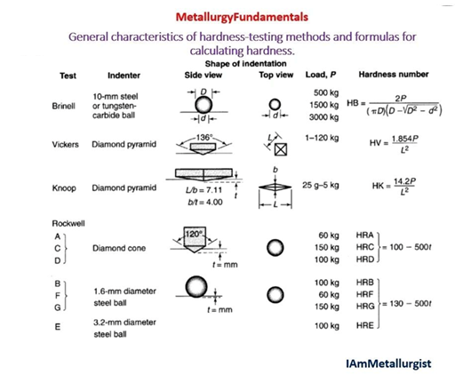

Indenters are essential components in hardness testing, designed to create controlled deformation in materials to measure their resistance to indentation, scratching, or impact. Different hardness tests use various indenter shapes and materials based on the properties of the material being tested. Diamond pyramid indenters, used in Vickers and Knoop hardness tests, have a 136° pyramidal shape (Vickers) or an elongated shape (Knoop) and are ideal for testing thin films, coatings, and microstructures due to their precision. Steel or tungsten carbide ball indenters, used in Brinell and Rockwell B hardness tests, come in spherical shapes, typically 10 mm in diameter, and are suited for soft to medium-hard metals like aluminium and copper. The diamond cone indenter, used in Rockwell C and A scales, features a 120° conical shape and is used for hard materials like hardened steel and alloys.

For scratch and rebound hardness tests, Mohs hardness indenters use reference materials such as glass, copper, or diamond to determine a material's scratch resistance. Leeb rebound hardness testers use a steel or tungsten carbide impact body to measure elasticity in large industrial components, while Shore durometer hardness testers use a spring-loaded needle or ball for testing rubber and polymers. Each indenter type is selected based on material properties, required accuracy, and testing conditions, ensuring precise hardness measurement across different industries and applications.

### MATERIALS AND EQUIPTMENT REQUIRED:

**Vickers Hardness Testing Machine**

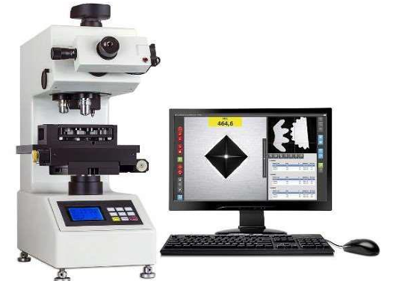

The Vickers Hardness Testing Machine is a precision instrument used to measure the hardness of materials, particularly metals, alloys, and thin coatings. It operates by pressing a diamond pyramid-shaped indenter into the material under a controlled load, typically ranging from 1 gf to 100 kg. The indentation left on the surface is measured using an optical microscope, and the Vickers Hardness Number (VHN) is calculated. The machine consists of essential components such as the indenter, load application system, sample holder (anvil), optical system, control panel, and a sturdy frame to ensure stability and accuracy. It is widely used in metallurgy, manufacturing, aerospace, and research due to its ability to test both macro and microhardness with high precision.

**Mild Steel sample**

Mild steel is a low-carbon steel (0.05–0.25% carbon) known for its ductility, weldability, and toughness. It is widely used in construction, automotive, and manufacturing due to its balance of strength and affordability. Mild steel has a Young’s modulus of approximately 200 GA, a Poisson’s ratio of around 0.29, and a hardness range of 120–180 HV (Vickers Hardness). It is not as hard as high-carbon steels but offers excellent machinability and formability.

**Sandpaper of Different Grids**

Sandpaper is a coated abrasive used for smoothing, polishing, and shaping surfaces in woodworking, metalworking, and automotive finishing. It consists of abrasive grains like aluminium oxide, silicon carbide, garnet, and ceramic bonded to a flexible backing such as paper, cloth, foam, or film. Grit size determines coarseness, with 40–80 for heavy removal, 100–150 for general sanding, 180–240 for surface prep, and 800–2000+ for polishing. Aluminium oxide is durable for wood and metal, silicon carbide is best for wet sanding, garnet is for wood finishing, and ceramic is used in industrial sanding. Cloth-backed sandpaper is durable for metal, foam-backed conforms to curves, and film-backed allows precision sanding. Sandpaper is essential for removing rust, preparing surfaces for paint, and polishing metals, glass, and plastics, making it highly versatile.

### OBSERVATIONS:

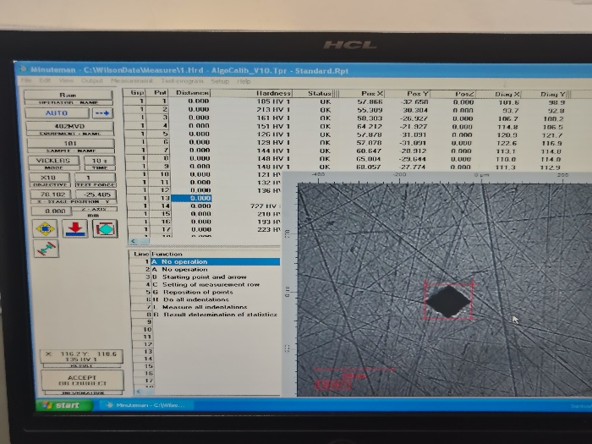

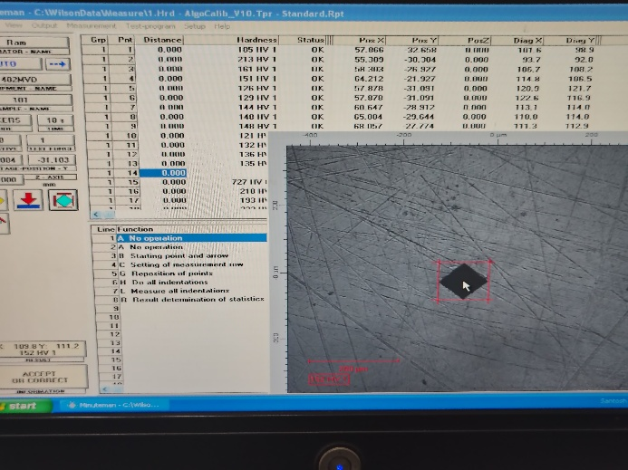

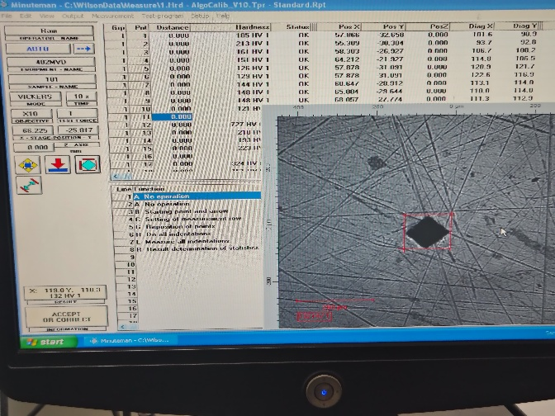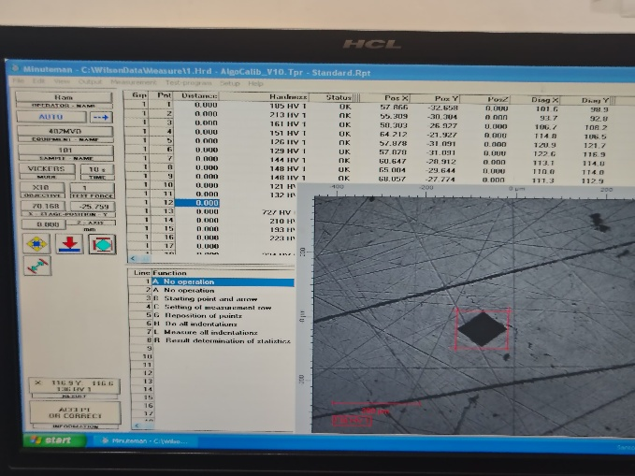

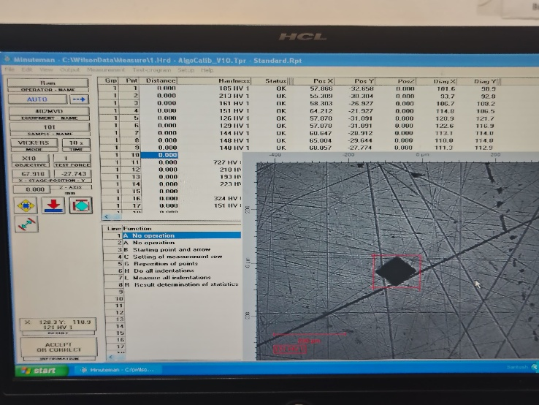

### TABLE:

|  |  |
| --- | --- |
| **Test Force=** 0.3 Kg F | |
| **Serial Number** | **Hardness Number** |
| **1.** | 152 |
| **2.** | 135 |
| **3.** | 136 |
| **4.** | 132 |
| **5.** | 121 |
| **Average Value of Hardness=** 135.2 HV | |

### COMPARISION WITH THEORY:

In this experiment, we conducted the Vickers Hardness Test to determine the hardness of mild steel using a Vickers hardness testing machine. The theoretical hardness of mild steel typically ranges between 200 to 230 HV, depending on its composition and processing conditions. Our experimental results closely align with this theoretical range, confirming the reliability of the test procedure. The high hardness of mild steel, as verified experimentally, enhances its mechanical strength, wear resistance, and durability, making it suitable for various engineering applications, including structural components, machinery parts, and automotive frames. This comparison with theoretical values validates the accuracy of the Vickers test and reinforces the importance of hardness testing in material selection and quality control.

### CONCLUSION AND DISSCUSSION:

The Vickers Hardness Test was performed on a mild steel sample, yielding a hardness value of 135.2 HV. This indicates that mild steel has moderate hardness, making it suitable for general engineering applications but less ideal for components subjected to high wear and friction. To enhance durability and reduce wear, materials with higher hardness should be used, especially in heavy machinery, construction, and moving components like gears and bearings, where resistance to deformation and abrasion is crucial.

The Vickers Hardness Test is widely used for assessing the microhardness of materials, providing accurate insights into their mechanical properties. However, the reliability of the test depends significantly on proper sample preparation. Before testing, the base of the sample was levelled to prevent inaccuracies in indentation measurement. Additionally, the surface was polished using different grades of sandpaper until a mirror-like finish was achieved. This step was necessary to eliminate scratches, as surface imperfections can distort the indentation and lead to incorrect hardness values.

This hardness test has extensive industrial applications, including metallurgy, manufacturing, and quality control. It is used to evaluate structural materials, coatings, and metal alloys, ensuring that the selected materials meet the required strength and durability standards for engineering applications. The results of this experiment emphasize the importance of choosing materials based on hardness requirements to improve performance and longevity in mechanical systems.

### ADDITIONAL DISCUSSION:

**Scratch Hardness**

Scratch hardness measures a material’s resistance to surface damage from a harder object, essential for evaluating coatings, minerals, and metals. Unlike indentation hardness, it focuses on surface penetration resistance. The Mohs Hardness Test ranks materials from 1 (talc) to 10 (diamond) based on their ability to scratch each other. Other methods include the Reve test (Erichsen Test) for coatings and the Martens Hardness Test for fine surface analysis. Key factors influencing scratch hardness include material composition, surface finish, coatings, and applied load. Harder materials like ceramics and carbides offer greater resistance, while protective coatings such as diamond-like carbon (DLC) enhance durability.

**Rebound Hardness**

Rebound hardness measures a material’s ability to resist deformation by evaluating its elastic recovery after impact. Unlike scratch and indentation hardness, it assesses elasticity and energy absorption. It is determined through dynamic impact tests, where an indenter is dropped, and the rebound height or velocity is measured. The Leeb Hardness Test (HL), using a tungsten carbide ball or diamond indenter, is ideal for large industrial parts. The Shore Ceroscopy Test drops a diamond-tipped hammer to measure rebound height, commonly used for metals and elastomers, while the Bennett Hardness Test assesses softer materials using an oscillating hammer. Factors affecting rebound hardness include material elasticity, surface finish, indenter type, and test orientation. More elastic materials rebound higher, while surface roughness and defects impact accuracy. Diamond indenters provide precise readings, whereas steel balls suit softer materials.

**Resilience**

Resilience is a material’s ability to absorb energy and return to its original shape after deformation, representing its elastic behaviour. It is crucial in applications where materials must withstand repeated or sudden loads without permanent damage. Modulus of Resilience (Ur), defined as the maximum elastic energy per unit volume before yielding, depends on yield strength and Young’s modulus. Unlike toughness, which measures total energy absorption before fracture, resilience focuses on energy storage within the elastic limit. Factors like material composition, elastic modulus, temperature, and microstructure influence resilience. It is measured through tensile, impact, and bending tests. Resilient materials are essential in automotive springs, aerospace structures, shock absorbers, and biomedical implants, ensuring durability under repeated stress.

### REFRENCES:

* <https://en.wikipedia.org/wiki/Vickers_hardness_test>
* <https://www.zwickroell.com/industries/metals/metals-standards/vickers-test-iso-6507/>
* <https://sm-nitk.vlabs.ac.in/exp/vickers-hardness-test/theory.html>
* <https://www.emcotest.com/en/hardness-knowledge/overview-of-hardness-testing-methods/vickers-hardness-test>